URL Shortener

URL shortening is a technique used to create shorter aliases for long URLs, making them easier to share, manage, and analyse.

Why Do We Need URL Shortening?
- Space Efficiency
- User Experience
- Branding and Customization

Functional Requirements
- Shorten a long URL → return short URL
- Redirect short URL → original long URL
- Same long URL → always same short URL (no duplicates)
- Short URLs expire after X days
- Track click count per short URL

Non-Functional Requirements
- High Availability: The service must be highly available, ensuring that URL redirections are always functional.
- Low Latency: Redirection should occur in real-time with minimal delays.

Back of the envelope estimation
Traffic Estimation
The system is expected to be read-heavy with more redirections than new URL shortenings. Let us assume that 100:1 read is to write ratio be ie 100(redirections):1(shorten URLS).
- New URL shortenings: 500 M per month
- Read/Write ration :100:1
- Redirections per month: 50B (100*50)
Write QPS: 500M / (30 * 24 * 3600) ≈ 200 URLs/s
Read QPS: 100 * 200 URLs/s = 20K/s

Storage Estimation
Assuming we have 500 million URLS per month and we have to store for 5 years
- Total URLs: 500M * 12 months * 5 years = 30 billion URLs
- Storage Requirement: With each URL requiring ~500 bytes, the total storage needed is:
- 30B URLs * 500 bytes = 15 TB
Bandwidth Estimation
- Write Requests: 200 URLs/s * 500 bytes = 100 KB/s incoming data.
- Read Requests: 20K URLs/s * 500 bytes = 10 MB/s outgoing data.

API Endpoints
According to our requirement we may need three API endpoints.
1)POST API for URL Shortening
Endpoint: createURL(api_dev_key, original_url, custom_alias, user_name, expire_date)

2)GET API for URL Redirecting
redirectURL(api_dev_key, short_url_key)

3)DELETE API to delete the short URL
deleteURL(api_dev_key, short_url_key)

DB Design
A URL shortening service is read-heavy and requires horizontally scalable storage. We need to store:
- User details
- Mappings of long URLs to their corresponding short URLs

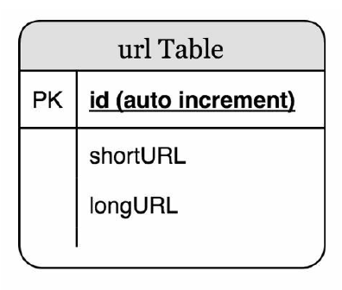
How to ensure no duplicates and generate unique short keys?
Schema:
id (AUTO_INCREMENT PK) | short_key (UNIQUE) | long_url (UNIQUE) | expiry_time | click_count
- long_url UNIQUE → prevents duplicate long URLs + auto creates index + handles race conditions
- short_key UNIQUE → prevents duplicate short keys + auto creates index
- id AUTO_INCREMENT → drives short key generation
Why SQL over NoSQL? AUTO_INCREMENT and UNIQUE constraints are native SQL strengths. Our data is flat and structured — perfect fit.

How will we generate hashValue to be attached in tinyURL?( www.tinyurl.com/{hashValue})

Hash function
The hash function is used to convert the long URL to short URL. For this first we calculate the hashValue length. From our back of envelope estimation we came to know that system has to support 365 billion records that is we have to find the smallest n such that 62^n
≥ 365 billion. So upon calculation we find that n=7 will be approximately supporting 3.5 trillion records. So length of the hashValue is 7.

Two types of hash functions are

1)Hash + collision resolution
Here we use hash functions like CRC32, MD5, or SHA-1.

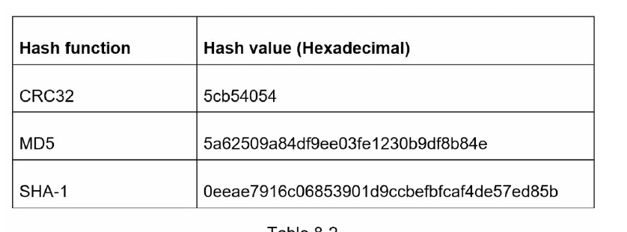

As shown in Table 8-2, even the shortest hash value (from CRC32) is too long (more than 7

characters). How can we make it shorter?

The first approach is to collect the first 7 characters of a hash value; however, this method

can lead to hash collisions. To resolve hash collisions, we can recursively append a new

predefined string until no more collision is discovered.
This method can eliminate collision; however, it is expensive to query the database to check
if a shortURL exists for every request.

Step 3 — Short Key Generation (Base62)
Problem: Convert large DB id into a short, URL-safe string.
Why Base62? 62 characters (a-z, A-Z, 0-9) — fully URL safe. Base64 has + and / which break URLs.
How it works:
1115710 = 2 x 622 + 55 x 621 + 59 x 620 = [2, 55, 59] -> [2, T, X] in base 62
Thus, the short URL is https://tinyurl.com /2TX
id = 1001 → divide repeatedly by 62, map remainders to charset → "qj"
6 characters → 62⁶ = ~56 billion unique URLs.
Uniqueness chain:
AUTO_INCREMENT ID (unique) → Base62 encode (deterministic) → unique short key
Different input always gives different output — no collision ever possible.
Final Deep Dive
1)URL Shortening
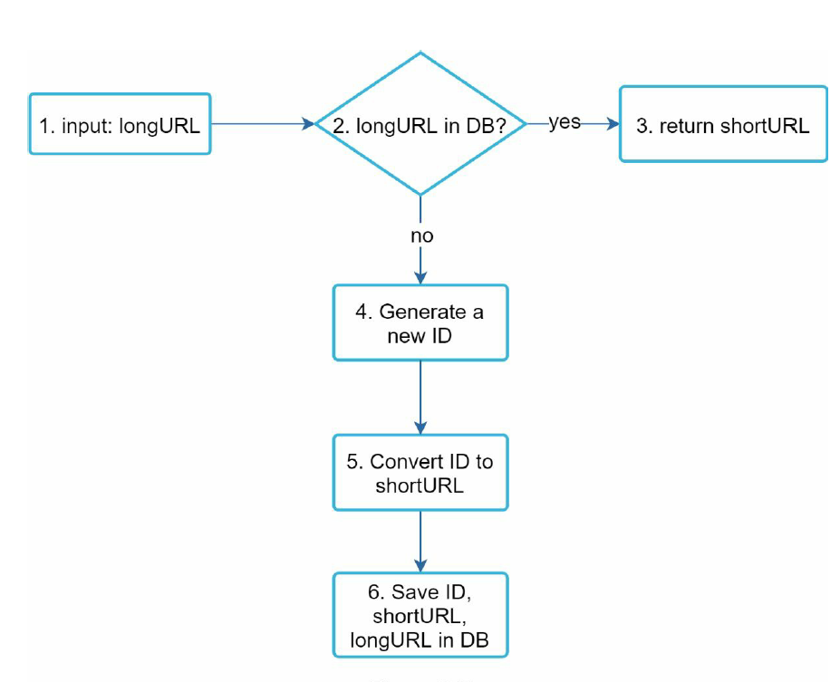
1. longURL is the input.
2. The system checks if the longURL is in the database.
3. If it is, it means the longURL was converted to shortURL before. In this case, fetch the
shortURL from the database and return it to the client.
4. If not, the longURL is new. A new unique ID (primary key) Is generated by the unique
ID generator.
5. Convert the ID to shortURL with base 62 conversion.
6. Create a new database row with the ID, shortURL, and longURL.

2)URL Redirecting
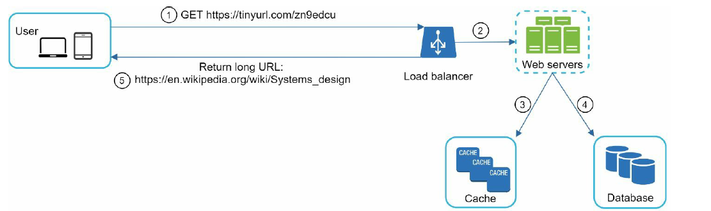

The flow of URL redirecting is summarized as follows:

1. A user clicks a short URL link: https://tinyurl.com/zn9edcu

2. The load balancer forwards the request to web servers.

3. If a shortURL is already in the cache, return the longURL directly.

4. If a shortURL is not in the cache, fetch the longURL from the database. If it is not in the

database, it is likely a user entered an invalid shortURL.

5. The longURL is returned to the user.

URL Expiry
Why? DB grows forever, dead URLs stay, business needs (campaigns, promos).
- expiry_time stored in DB
- On redirect → expired? → delete from DB → throw error (lazy delete)
- Cache TTL = remaining expiry time
- Default = 30 days (configurable)
Problem: Nobody clicks expired URL → stays in DB forever → DB keeps growing.
Solution: Background cleanup job runs every 24 hours:
sql
DELETE FROM url_mapping WHERE expiry_time < NOW()
Two layers of expiry cleanup:
Layer 1 → Lazy delete : Someone clicks expired URL → delete immediately
Layer 2 → Background job : Every 24 hours → bulk delete all expired URLs

Redis Cache
Problem: Read heavy system — 1M redirects → 1M DB queries → DB crashes.
Why cache? DB = ~100ms, Cache = ~1ms (100x faster).
Two mappings cached per URL:
shortKey → longUrl (redirect)
longUrl → shortKey (duplicate check)
Cache-aside pattern: Check cache → miss → fetch DB → store in cache.
TTL = remaining URL expiry time → cache and DB always in sync.

Cache Memory & Eviction
Problem: Unlimited cache entries → RAM full → Redis crashes.
Solution:
maxmemory = 2gb
maxmemory-policy = volatile-lru
Why volatile-lru?
- Cache keys → have TTL → eligible for eviction ✅
- Counter keys → no TTL → never evicted ✅
- allkeys-lru would evict counter keys too ❌
Two cleanup layers:
TTL → expired URLs auto-deleted
LRU Eviction → least used URLs removed when memory full

Rate Limiting (Token Bucket)
Problem: Bots flood system → server crashes.
Token Bucket:
Capacity = 100 tokens, Refill = 10/second
Each request consumes 1 token
No tokens → 429 Too Many Requests
Why Token Bucket over Sliding Window? Sliding Window blocks legitimate burst traffic (e.g. campaign launch). Token Bucket allows controlled bursts then throttles. ✅
Why Redis for rate limiting? Without Redis — each server tracks independently → rate limit bypassed across servers. With Redis — shared count across all servers → correctly enforced. ✅

